2021
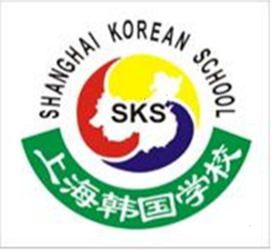

Shanghai Korean School

POSITION: Full time NATIVE ENGLISH TEACHER – Primary School
The Primary English Department of the Shanghai Korean School is looking for qualified EFL teachers, to begin week commencing August 23rd 2021.
SKS is a regular government school based in Minhang, Shanghai serving Korean students from grades 1-12. This position is for primary school children in grades 1-6.
Candidates must be able to work Mon—Fri 8:20am to 4:20pm.
Teachers are responsible for up to 22 class periods per week with the remaining time being devoted to lesson planning and departmental duties. One class period is 40 minutes.

Qualifications and Experience:
- University degree (at least a BA or BS) (Education or English preferred)
- CELTA , TESOL or TEFL certificate
- Native English Speaker
- More than 2 years’ teaching experience

Remuneration:
- full-time base salary- RMB 23000 (after tax) inclusive of housing allowance. Incremental rises after each year completed
- FULLY paid winter and summer vacations (5 weeks in summer and 5 weeks in winter)
- qualification bonuses may apply
- MUST currently reside in China

How to apply:
Please email the required documents together with your CV and cover letter
To Sam Thornber (sthornber900411@hotmail.com) or We Chat: Sam4111990

